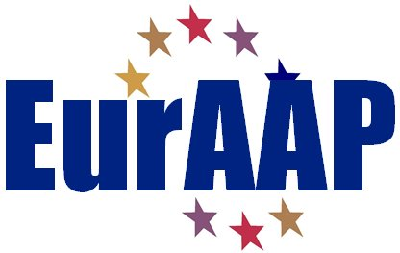

NOMINATION FORM FOR THE 2024 EurAAP AWARDS
The EurAAP Awards are two: one in the Antenna field and one in the Propagation field. They recognize the contribution to technical & scientific advances, education, and coordination of research & networking activities in the Antennas & Propagation field in Europe or having a relationship to Europe.

AWARD FOR WHICH THE NOMINATION IS MADE
Please select one of the following
  - EurAAP Antenna Award
  - EurAAP Propagation Award

NOMINEE
  - Name of Nominee: Name
  - Professional Affiliation and Title: Affiliation & Title
  - Address:
Address.
  - E-mail: e-mail.
  - Education (Institution, location, degree, and year received)
Education.
  - Description of current activities:
Activities.
  - Achievement pertinent for the Award and justification of its relevance:
Achievements.
  - Proposed citation:
Citation (max. 30 words).

NOMINATOR
  - Name: Name.
  - Professional Affiliation and Title: Affiliation & Title
  - Address:
Address.
  - E-mail: e-mail.
  - Relationship to the Nominee:
Relationship.

Endorsers
Names and Addresses, Emails:

Note: the nomination form, except for the endorsement letters, should not exceed five pages in length (minimum 10-point font size).

Please complete and send the form as PDF to:
EurAAPAwards@euraap.org

Endorsement letters may accompany the nomination or be sent separately.
The nominator is responsible for submitting all the materials.

